**Excel Assignment - 6**

1. **What are the various elements of the Excel interface? Describe how they're used.**

The Excel interface consists of various elements that allow you to navigate, create, and manage spreadsheets. Here are the main elements of the Excel interface and their common uses:

1. Title Bar: The title bar is at the top of the Excel window and displays the name of the current workbook. It also contains the standard window control buttons (Minimize, Maximize/Restore, Close) for managing the Excel application window.

2. Ribbon: The ribbon is located just below the title bar and is divided into tabs, each containing various commands and options. It provides access to all the features and functions in Excel, organized into categories like "File," "Home," "Insert," "Page Layout," "Formulas," "Data," "Review," and "View." You can click on the tabs and buttons to access and use Excel's many features.

3. Quick Access Toolbar: This is a customizable toolbar located above the ribbon. You can add frequently used commands to the Quick Access Toolbar for quick access. To add a command, right-click it in the ribbon and select "Add to Quick Access Toolbar."

4. Formula Bar: The formula bar is just below the ribbon. It displays the contents of the active cell and allows you to enter or edit data, formulas, or functions in a cell. You can also use it to view and edit the formula of the selected cell.

5. Column and Row Headers: Excel sheets are organized into columns labeled with letters (A, B, C, etc.) and rows labeled with numbers (1, 2, 3, etc.). You can use these headers to reference specific cells or ranges in your spreadsheet.

6. Worksheet Tabs: At the bottom of the Excel window, you'll find worksheet tabs that allow you to navigate between different worksheets within a workbook. You can add, delete, and rename worksheets as needed.

7. Scroll Bars: Scroll bars are located on the right and bottom of the worksheet area. You can use them to scroll through the content of the worksheet when it doesn't fit in the visible area.

8. Status Bar: The status bar is at the bottom of the Excel window. It provides information about the current status of your workbook, including sum, average, count, and other details about selected cells. It also allows you to change view settings and zoom levels.

9. Workbook Area: The majority of the Excel interface is occupied by the workbook area. This is where you input and edit data, use formulas and functions, create charts, and perform various tasks related to your spreadsheet.

10. Cell: The individual rectangular boxes within the workbook area are called cells. You can enter data, formulas, or functions into cells and format them as needed.

11. Name Box: The name box is to the left of the formula bar. It displays the cell reference of the currently selected cell, which is helpful for navigation and referencing cells in formulas.

12. Zoom Slider: Located at the bottom-right corner of the Excel window, the zoom slider allows you to adjust the zoom level to make your worksheet appear larger or smaller on the screen.

These are the key elements of the Excel interface. Understanding how to use these elements effectively will help you create, edit, and manage your spreadsheets efficiently.

2. **Write down the various applications of Excel in the industry.**

Excel is a versatile and widely used spreadsheet software with numerous applications across various industries. Some of the common applications of Excel in different industries include.

1. Finance and Accounting:

- Financial modeling and analysis.

- Budgeting and forecasting.

- Investment analysis.

- Accounting and bookkeeping.

- Risk assessment and management.

2. Business Management:

- Data analysis and reporting.

- Project management and tracking.

- Employee scheduling and resource management.

- Inventory management and tracking.

- Customer relationship management (CRM) data analysis.

3. Marketing and Sales:

- Sales tracking and analysis.

- Marketing campaign analysis.

- Customer data management.

- Lead tracking and conversion analysis.

- Market research and data visualization.

4. Human Resources:

- Payroll processing and analysis.

- Employee performance evaluations.

- Recruitment and applicant tracking.

- Workforce planning and scheduling.

- Training and development tracking.

5. Manufacturing and Supply Chain:

- Inventory management and optimization.

- Production planning and scheduling.

- Quality control and process monitoring.

- Supplier and vendor management.

- Supply chain analysis and optimization.

6. Healthcare and Life Sciences:

- Patient data management and analysis.

- Clinical trial data analysis.

- Medical research and data visualization.

- Drug development tracking.

- Healthcare resource allocation.

7. Education:

- Grade and attendance tracking for teachers.

- Educational data analysis and reporting.

- Budgeting and financial management for educational institutions.

- Student performance tracking.

- Lesson planning and curriculum development.

8. Real Estate:

- Property management and rental income tracking.

- Real estate investment analysis.

- Mortgage and loan calculations.

- Property valuation and appraisal.

- Market analysis and property listings.

9. Engineering and Construction:

- Project cost estimation and tracking.

- Resource allocation and project scheduling.

- Material and equipment inventory management.

- Structural and engineering calculations.

- Quality control and inspection tracking.

10. Research and Data Analysis:

- Data collection and organization.

- Statistical analysis and hypothesis testing.

- Data visualization and charting.

- Experiment and survey data analysis.

- Report generation and documentation.

11. Government and Public Administration:

- Budget planning and allocation.

- Public policy analysis.

- Data management for government agencies.

- Reporting and data visualization for public services.

- Election data analysis.

12. Nonprofit and NGOs:

- Donation and grant tracking.

- Fundraising and donor management.

- Program and project management.

- Impact assessment and reporting.

- Volunteer and resource coordination.

These are just a few examples of how Excel is used across various industries. Its flexibility, ease of use, and powerful data analysis capabilities make it a valuable tool for professionals in many different fields.

3**. On the ribbon, make a new tab. Add some different groups, insert commands in the groups and name them according to their commands added. Copy and paste the screenshot of the steps you followed.** 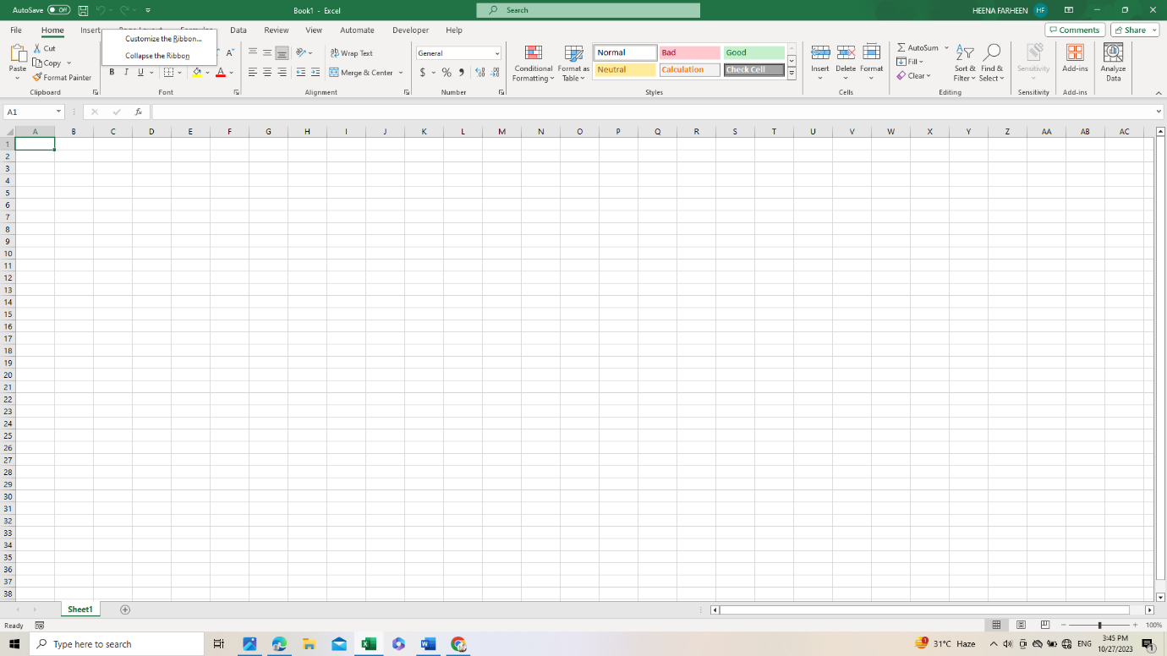

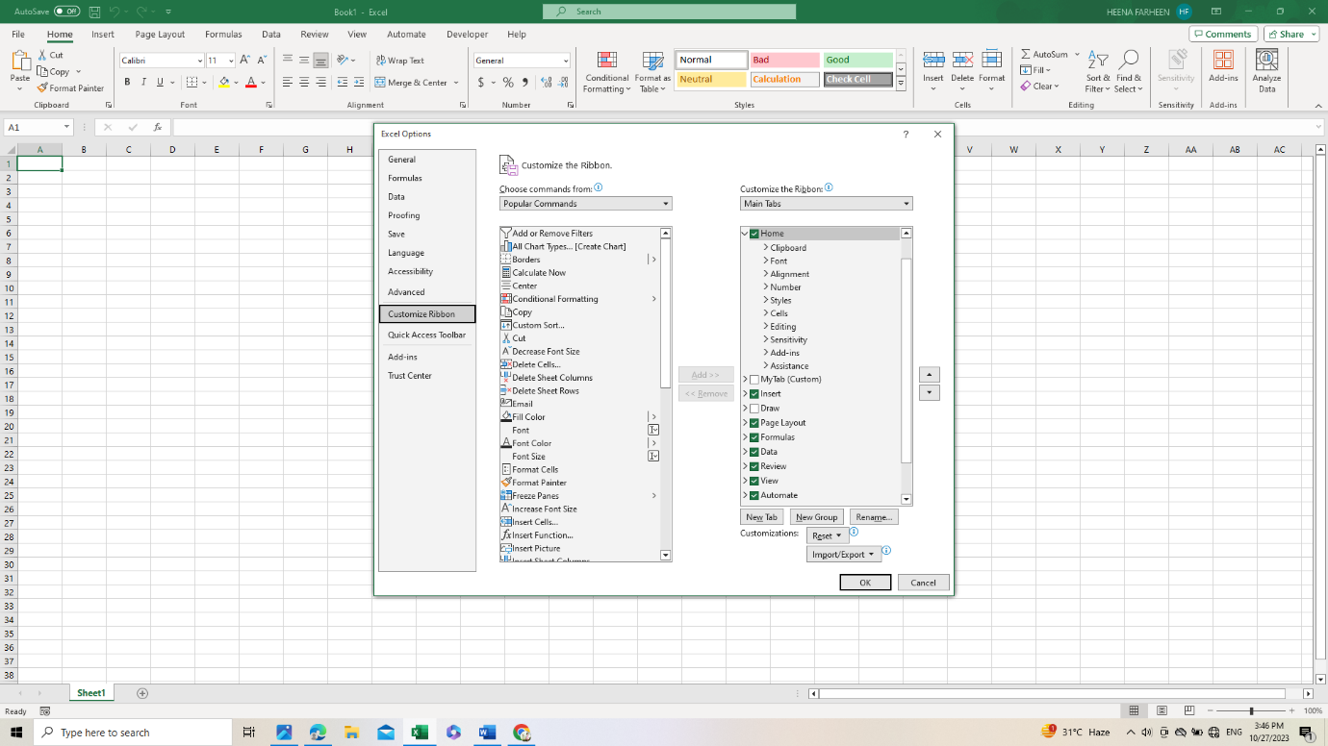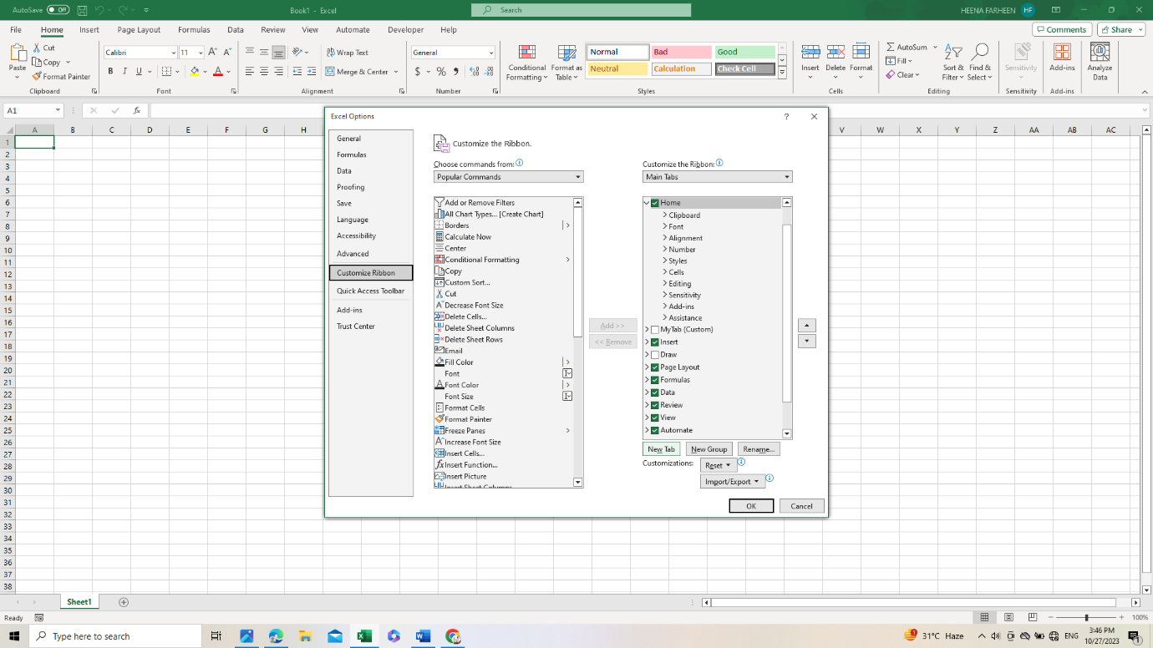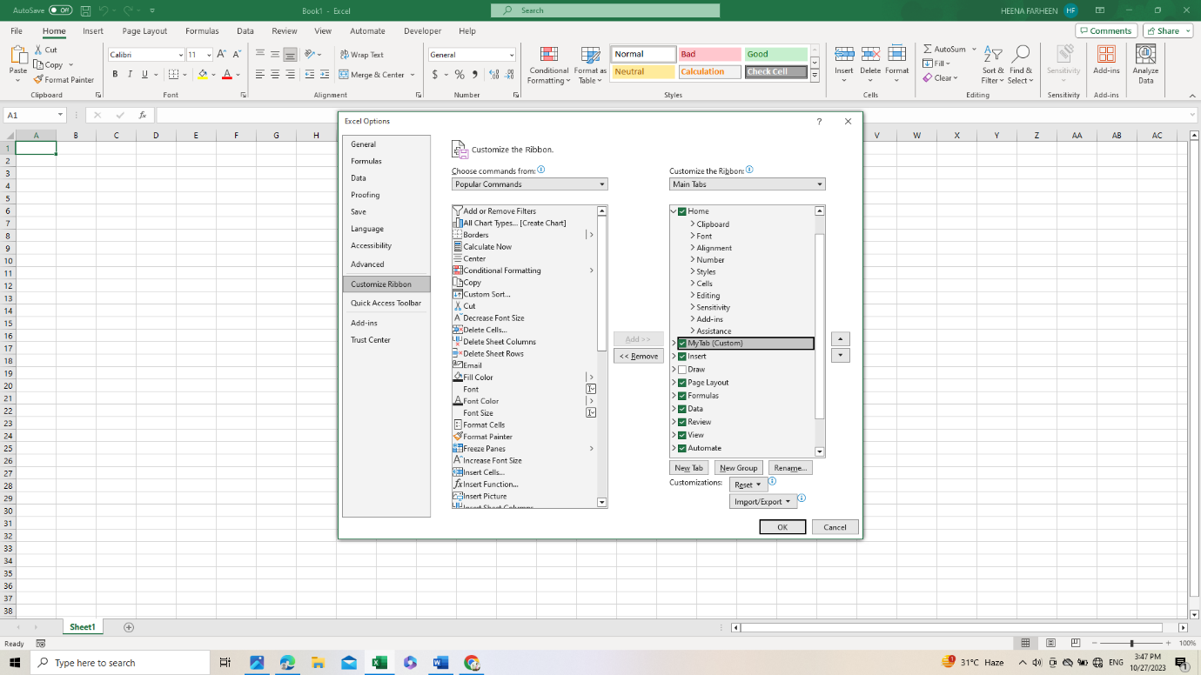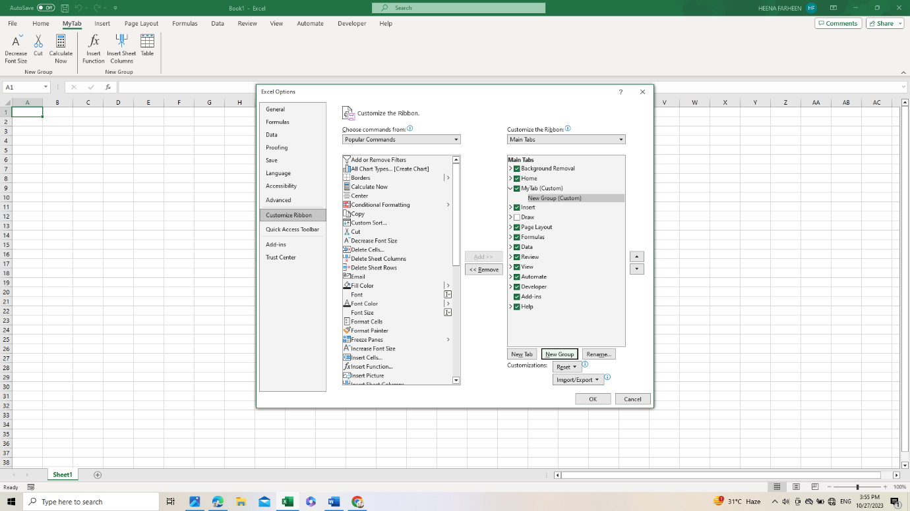

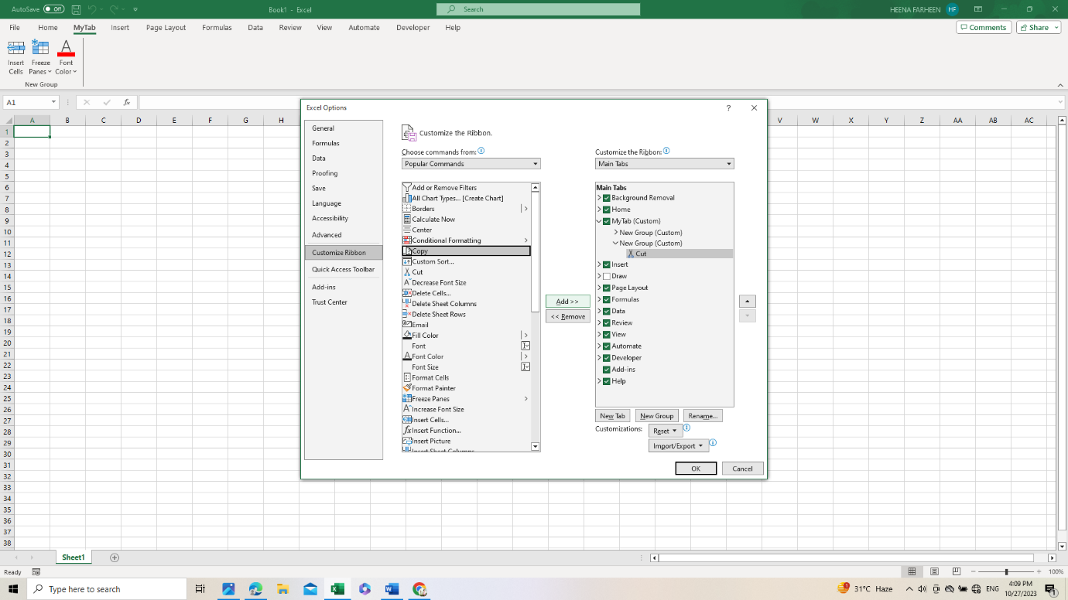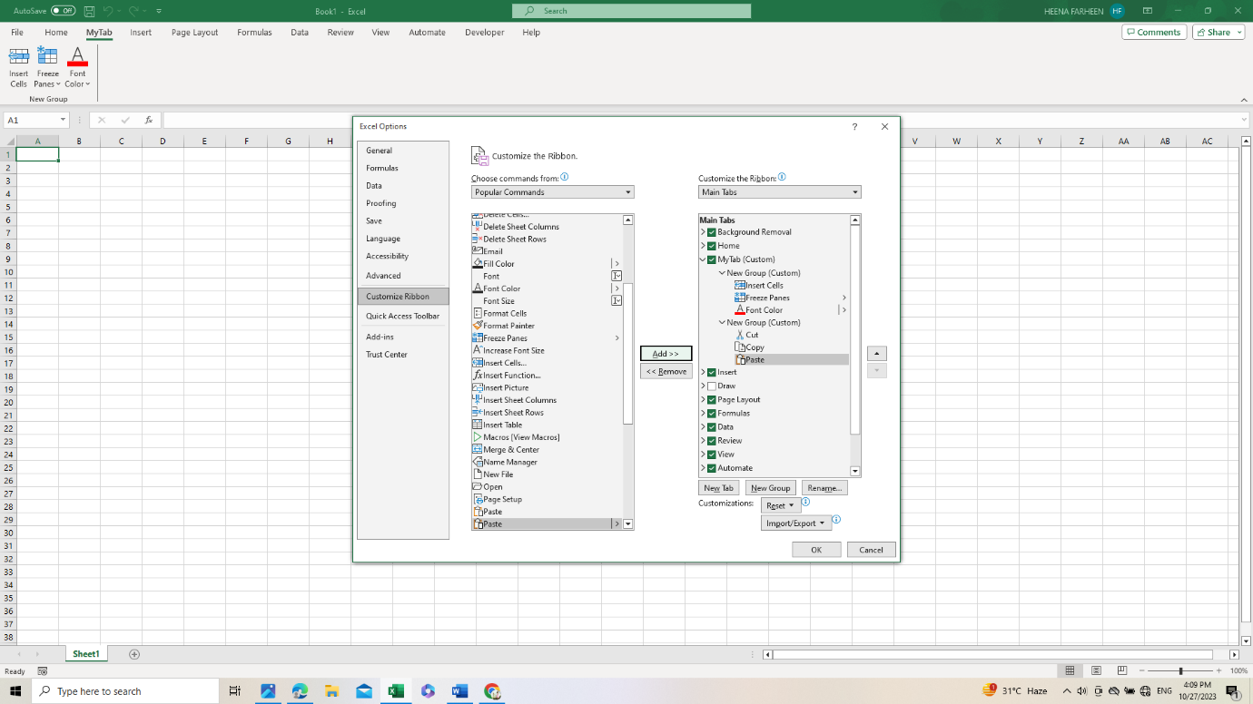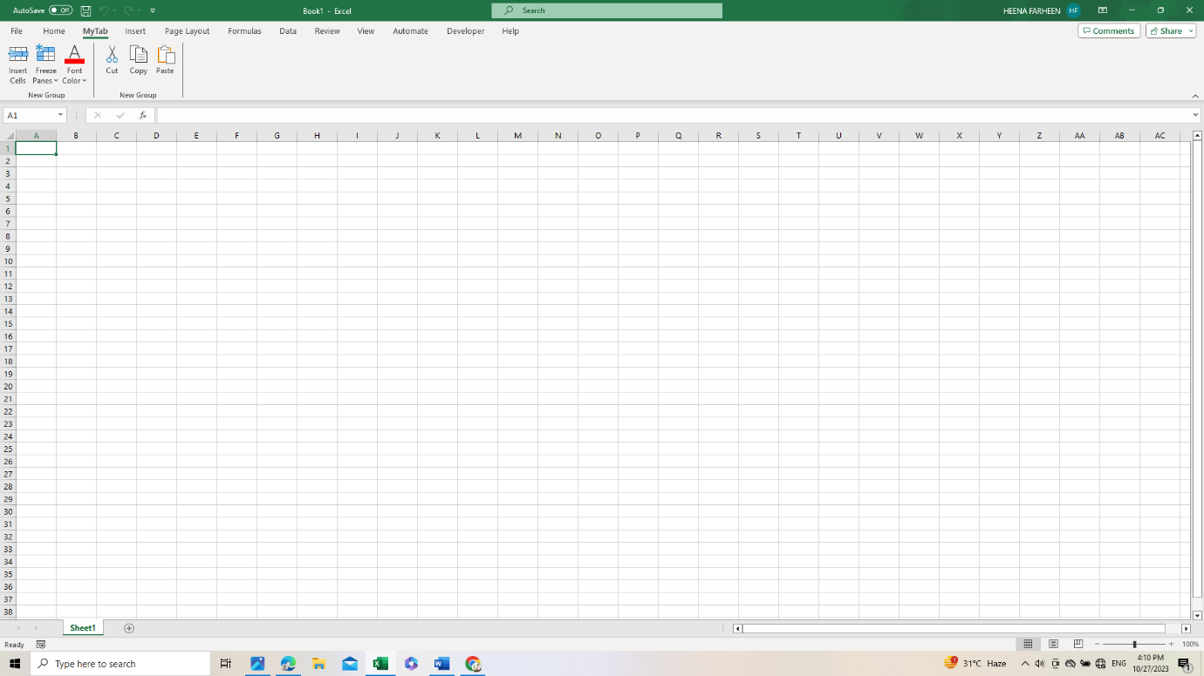

4. **Make a list of different shortcut keys that are only connected to formatting with their functions.**

Certainly, here is a list of some common formatting-related shortcut keys in Excel and their functions:

1. Ctrl + B: Bold - Applies or removes bold formatting from selected text or cell contents.

2. Ctrl + I: Italic - Applies or removes italic formatting from selected text or cell contents.

3. Ctrl + U: Underline - Applies or removes underline formatting from selected text or cell contents.

4. Ctrl + 1: Format Cells - Opens the Format Cells dialog, allowing you to apply various formatting options such as number formats, borders, and font styles.

5. Ctrl + 5: Strikethrough - Applies or removes strikethrough formatting from selected text.

6. Ctrl + Shift + L: Create or Remove Bulleted List - Converts selected text or a cell range into a bulleted list or removes the bullet formatting from a bulleted list.

7. Ctrl + Shift + -: Delete - Allows you to delete rows, columns, or cells.

8. Alt + H, H: Hide Row or Column - Hides the selected row or column.

9. Alt + H, U, L: Unhide Rows or Columns - Unhides previously hidden rows or columns.

10. Ctrl + Shift + + (Plus Sign): Insert - Allows you to insert rows, columns, or cells.

11. Ctrl + 5: Apply or Remove Strikethrough - Adds or removes strikethrough formatting from the selected text.

12. Ctrl + Shift + C: Copy Formatting - Copies the formatting of the selected cell or text and applies it to another cell or text.

13. Ctrl + Shift + V: Paste Formatting - Applies the formatting copied using Ctrl + Shift + C to another cell or text.

14. Ctrl + 9: Hide Rows - Hides the selected rows.

15. Ctrl + Shift + 9: Unhide Rows - Unhides previously hidden rows.

16. Ctrl + 0: Hide Columns - Hides the selected columns.

17. Ctrl + Shift + 0: Unhide Columns - Unhides previously hidden columns.

5**. What distinguishes Excel from other analytical tools?**

Excel is a popular and versatile spreadsheet application, but it has several features and characteristics that distinguish it from other analytical tools. Here are some key points that set Excel apart:

1. User-Friendly Interface: Excel has an intuitive and user-friendly interface, making it accessible to a wide range of users, including those who may not have a strong technical background. This simplicity is especially valuable for beginners and small businesses.

2. Widespread Usage: Excel is one of the most widely used spreadsheet applications globally. This widespread adoption means that many people are already familiar with Excel and have experience using it.

3. Versatility: Excel is not limited to data analysis and reporting; it is a comprehensive tool that can be used for various tasks, including financial modeling, budgeting, project management, and more.

4. Customization: Users can create and customize Excel spreadsheets to suit their specific needs. Excel offers a wide range of functions and tools for data analysis, allowing users to tailor their solutions.

5. Integration: Excel easily integrates with other Microsoft Office applications, such as Word and PowerPoint, making it convenient for creating reports, presentations, and sharing data.

6. Formula Language: Excel's formula language is widely recognized and supported. Users can build complex calculations using Excel's functions and formulas.

7. Extensive Charting and Graphing: Excel offers a variety of chart types and options for visualizing data, from basic bar and pie charts to more advanced data visualization tools.

8. Data Visualization Tools: Excel provides features like PivotTables and PivotCharts, which allow for dynamic data analysis and reporting.

9. Add-Ins and Third-Party Extensions: Excel supports add-ins and third-party extensions that can enhance its functionality for specialized tasks.

10. Accessibility and Compatibility: Excel files can be easily shared and opened across different devices and operating systems. Additionally, it's compatible with various file formats, including CSV, TXT, and PDF.

11. Learning Resources: There are numerous online tutorials, courses, and resources available to help users learn Excel effectively.

12. Macros and VBA: Excel enables advanced users to automate repetitive tasks and create customized solutions using Visual Basic for Applications (VBA) programming.

6**. Create a table and add a custom header and footer to your table.**

